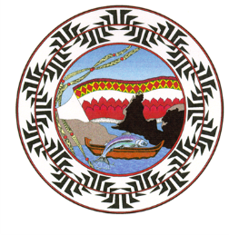 Yurok Tribal Elections
Run-Off
2024

VICE-CHAIRPERSON
Rose Sylvia
Phillip L. Williams

Run-Off Election Day is scheduled for November 13, 2024.

All ballots will be mailed to registered voters on October 18, 2024 and ballots must be received by 5pm on November 13, 2024.

For more information regarding the election, call the Election Department at
(707) 482-1350 or the tribal website: www.yuroktribe.org.

